Chapter 28 sample project report

Training data

I trained a one neuron linear classifier network and then refined its classification using a two neuron competitive network.

The network’s classification was good – all 200 good greebles were classified correctly, while 198/200 (99%) of the bad greebles were classified correctly. This is a very good classification rate. Also, as the graph below makes clear, the two misclassified bad greebles were ambiguously placed between the two clusters. It might have been possible to classify them as bad, but probably not without slandering the name of at least one good greeble.

Though this was not by design, I prefer misclassifying bad as good over misclassifying good as bad. To paraphrase Thomas Jefferson, “It is better for one hundred guilty greebles to go free than for one innocent greeble to go to jail.”

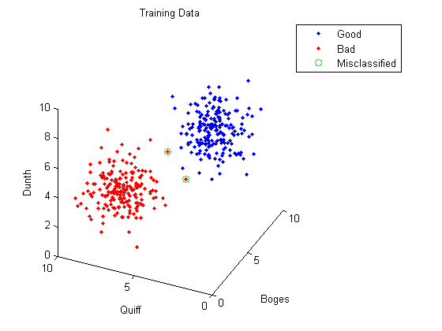
Test data

I then used my network to classify the 100 test greebles. I am very confidant in this classification, both because the training data was classified well (99.5% overall) and because there is such a clear separation between the bad cluster and the good cluster. There does not appear to be any ambiguous cases like there were in the training data (graph below).

